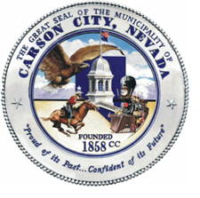
Letter of Intent to Apply
2024-2025 Community Support Services Grant (CSSG)
Due February 12, 2024, by 5:00 pm

Organization: Click or tap here to enter text.
Contact Name: Click or tap here to enter text.
Address: Click or tap here to enter text.
Telephone: Click or tap here to enter text.
Email: Click or tap here to enter text.
EIN: Click or tap here to enter text.

Is your organization:
A 501(c)3 nonprofit ☐ Yes ☐ No
Incorporation Date Click or tap here to enter text.
Based in Carson City ☐ Yes ☐ No
Serve Carson City citizens ☐ Yes ☐ No
Requested amount: Click or tap here to enter text.
__________________________________________________________________________________________
Does you project or program meet one of the critical needs listed below?
Mental Health
☐ Substance Abuse Services
☐ Domestic Abuse Services
Youth Services
Disabled Services
Health/Dental Services
Senior Services
__________________________________________________________________________________________
Please answer the following questions. The narrative should be no more than two pages.
- Please provide a brief overview of your organization.
- Please provide a project overview. Include a problem statement, proposed solution, and expected outcomes.
- What is your funding request? Please use the attached Proposed Budget Form.

Please submit this form, budget form, and Letter of Intent to:
Rebecca Phipps, Grants Administrator
Carson City, Department of Finance
201 North Carson Street, #3
Carson City, NV 89701
rphipps@carson.org

Invitations to apply will be sent in February 2023. Approval or disapproval of your submission is solely at the discretion of Carson City management.

